Printing to Envelopes
You can print to various sized labels as well as envelopes on your Canon device using the Multi-purpose tray.
Step 1: From a Microsoft Word document, select the Mailings Tab.
- From the Mailings Tab, select Envelopes.
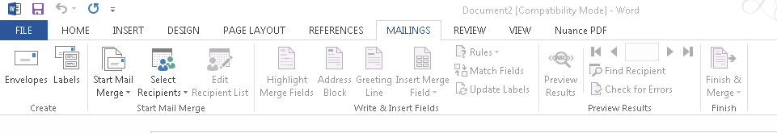
Step 2: From the Envelope Tab, enter the Delivery and Return Addresses in the appropriate field.
- Click Add to Document, and you will be prompted if you would like to add the Return Address as the default Return Address.
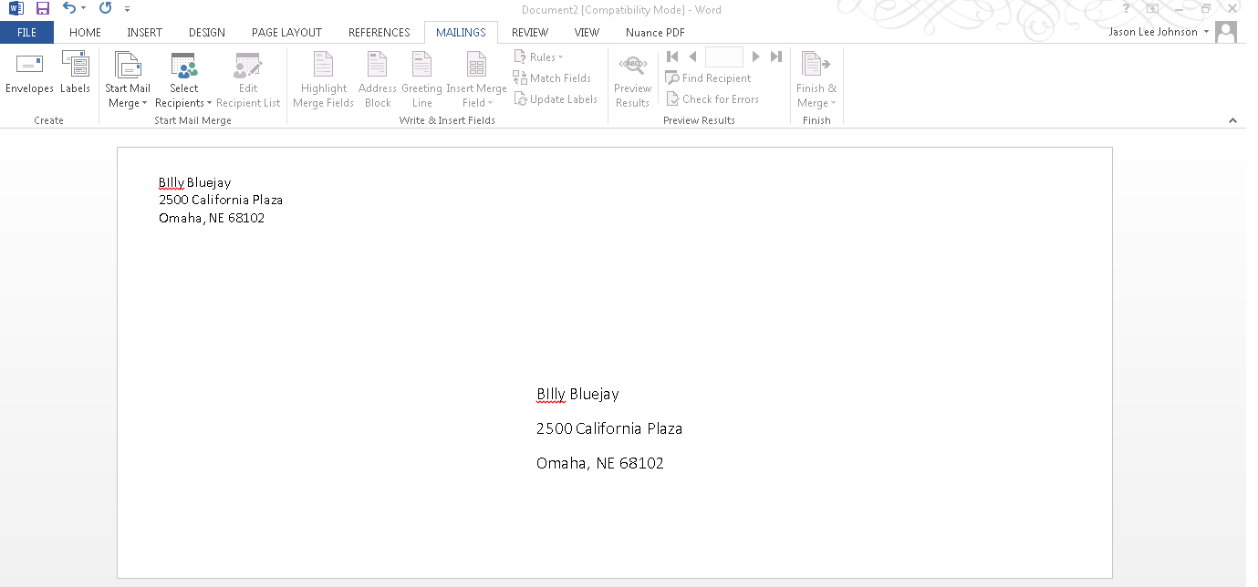

Step 3: Review your Destination and Return Address
- Click File, Print and Click on the Printer Properties.
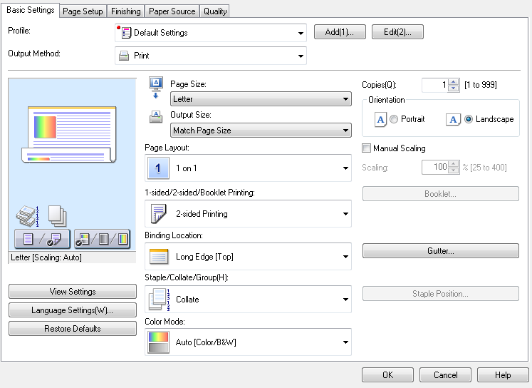
- Click the Page Size and select you appropriate Envelope Size.
- Click Paper Source and select the Multi-purpose tray.
- You can enter up to ten envelopes in to the Multi-purpose tray (you will be prompted at the device to select the appropriate envelope size).
- Your envelopes should be ready to print.

